Comp Sci 1

VB.NET
Selection Structure

“Space Race”

Objective: Work with visual basic timer object, val function, if statement and random numbers

Project Description:

The form should look like this:

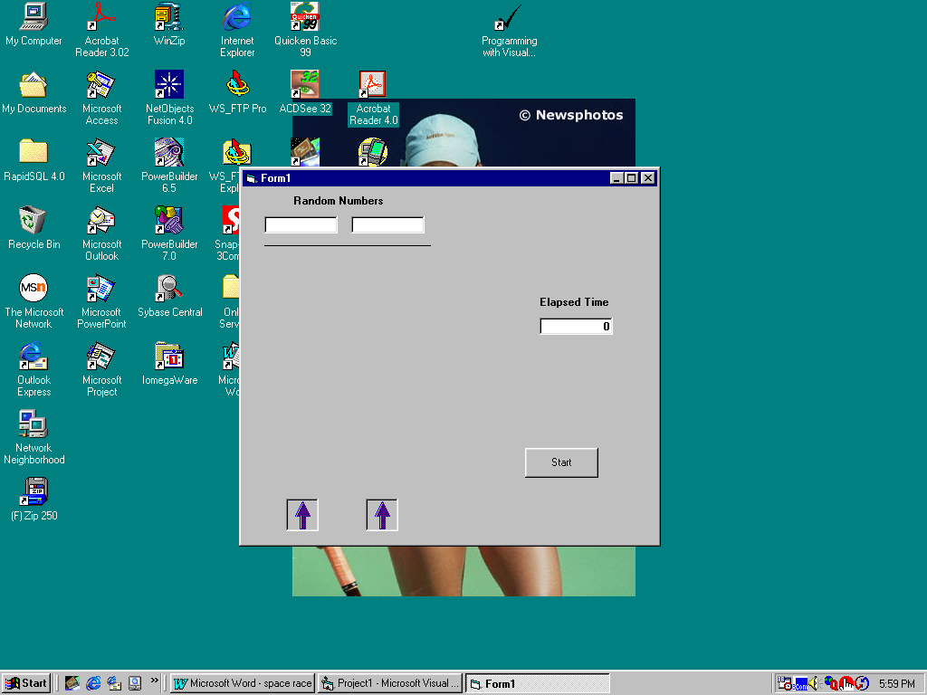

The end of the program should look like this:

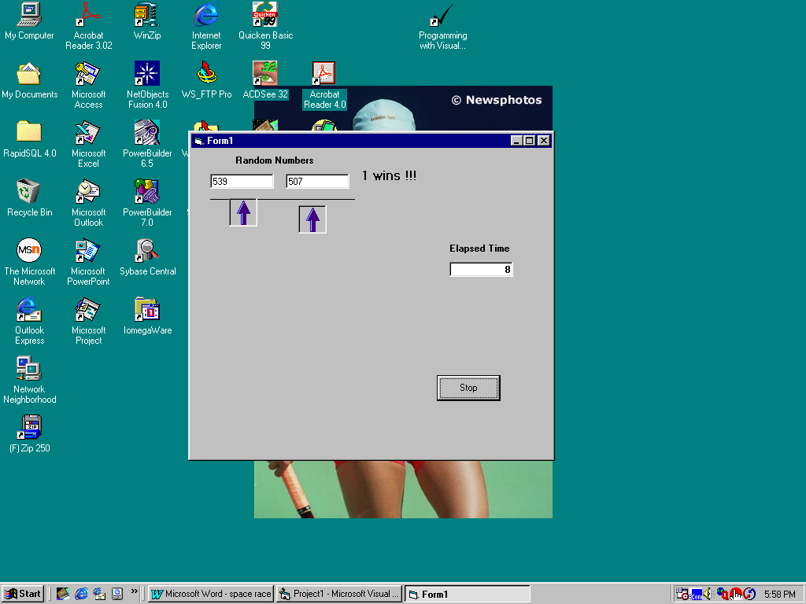
Create a form and add:

2 picture objects.

A timer object

a line object

several labels

3 text boxes

command button

The command button should allow you to start and stop the race.

Use the timer’s timer method to move the 2 pictures up the form until one crosses the finish line.

When one passes the finish line, stop the timer and declare the winner !!!

